**CE Web Site Article Content Authoring**

An article page in CE site is a two-column page layout that divides content into 2 areas:

1. Main content area on the left. This area occupied about 85% width of a CE web page. It can contain any html content.
2. Complimentary content area (called *sidebar*) on the right. This area is organized into *tiles*. Each tile is a display block with that renders content in different form. Three type of *tiles* are supported:

* Image tile - this type displays an image and a caption in the title.
* Related link tile – this type displays the related links with an icon and a linked text.
* Testimony tile – this tile display an icon, a title, and a testimony text.

Authoring CE site article content is a process of creating an xml file that describes the content of an article and hook it up with resources like documents, images, and web page. This process is described below.

**Step 1: Create article xml content file**

* Select a subfolder to create the article content file in.
* To start out an article xml file, use the article template file */content/article-template.xml*. Make a copy of the template, rename it to a content filename you want, and then move it to the content folder the content file belongs to.
* Add your content for the article. The best way is to use an existing article content file as example to do your editing.

**Step 2: Add resource files**

* If your article content refers to other resources, such as documents or images, add those resources to their proper folders. It is recommended that all documents go to *Documents* folder and all images go to *Images* folder. Note that *Documents* and *Images* have corresponding subfolder structure as *Content* folder.
* Make a proper URL reference in your content file for those resources.

**Step 4: Add content page link to CE Site**

* If your content page is to be accessed via menu, you need to edit /content/cemenu.xml to make a link to it.
* If your content page is to be accessed from other page, edit that page to make a link to it.

**Step 3: Create web page file for the content**

There is a page generator tool in CE site to help you create a web page to render your content. Please refer to document *Generating CE Web Page for Content* for details.

**Step 5: Test your page**

Test your page to ensure sure it is rendered as intended.

**Sample screen shot for Article page**

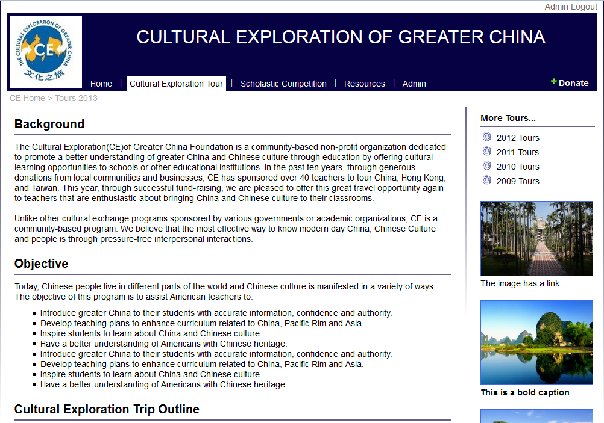

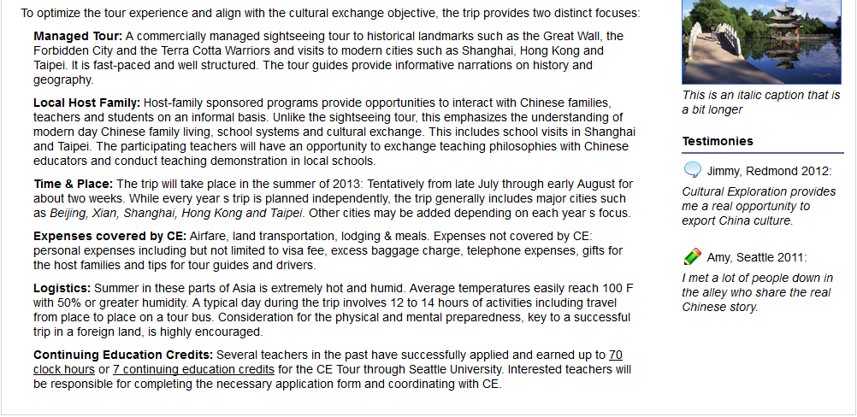

**Listing of article template file**

<?xml version="1.0" encoding="utf-8" ?>

<ce>

<page>

<articles>

<article title="...">

<paragraph>

<text>

<![CDATA[

put any text here including html tags or Chinese words.

]]>

</text>

</paragraph>

</article>

<article title="...">

<paragraph indent="false">

<text>

put any text here if you don't have html tags in the text.

</text>

</paragraph>

<paragraph indent="true">

<item>any text here will has sqaure bullet and indented.</item>

<item>repeat as needed</item>

</paragraph>

</article>

</articles>

<sideBar>

<relatedLinks header="Related Links">

<relatedLink iconUrl="/Images/at.png" title="2012 Tours" linkUrl="/public/articles/cearticle.aspx?theme=...&amp;path=/...&amp;content=..." />

</relatedLinks>

<barTiles>

<barTile caption="cpation text" imageUrl="/Images/..." linkUrl="/public/..." captionPosition="bottom" />

</barTiles>

<testimonies header="Testimonies">

<testimory caption="testimony title" text="testimy text goes here." iconUrl="/Images/..." linkUrl="/public/..." captionPosition="top" />

</testimonies>

</sideBar>

</page>

</ce>